Introduction 1
About the Author 1
Video 2
Social media 2
Available through ICT 2
Available for school visits 2
Art 2
Curriculum Connections 3
Your ideas 3
General capabilities: Ethical understanding 3
Sub-element ‘Exploring values, rights and responsibilities’ 3
General capabilities: Personal and Social Capability 4
Sub-element ‘Social awareness – Understand relationships’ 4
Sub-element ‘Appreciate diverse perspectives’ 4
General capabilities: Information and Communication Technology (ICT) Capability 5
General capabilities: Critical and Creative Thinking 5
Sub-element ‘Generating ideas, possibilities and actions’ 5
General capabilities: Literacy 5
Visual Arts 6

Professional Standards for Teachers 7
Standard 1.1: 7
Use teaching strategies based on knowledge of students’ physical, social and intellectual development and characteristics to improve student learning 7
Standard 1.6: 7
Design and implement teaching activities that support the participation and learning of students with disability and address relevant policy and legislative requirements. 7
Standard 4.1: 7
Establish and implement inclusive and positive interactions to engage and support all students in classroom activities. 7
Standard 4.4: 8
Ensure students’ wellbeing and safety within school by implementing school and/or system, curriculum and legislative requirements. 8
Standard 4.5: 8
Use ICT safely, responsibly and ethically. 8
Standard 7.3: 8
Establish and maintain respectful collaborative relationships with parents/carers regarding their children’s learning and wellbeing. 8
Conclusion 9
Bibliography 9
Online stories about Janelle 10
Janelle’s art online 10
General video resources 11

Introduction
Rafting: A wheelchair won’t stop us is the story of Trent’s rafting adventure with his friends. For this group of friends, though, going out on the river is not necessarily straight forward or simple, but with the wish to make sure Trent can experience the adventure with them, this group of friends make it happen!
The recurring elements of this story are friendships, inclusion and problem solving. Trent is upset when he thinks his friends might go on a rafting adventure without him. Those friends show that their friendship with Trent matters to them and that means finding ways to include Trent, rather than treating this as ‘too hard’. They make sure that Trent, a kid with cerebral palsy (a physical disability), can be part of the day’s adventure, with all of its laughs and dramas, challenges and new friendship moments, and the sheer exhaustion of a day of adventure.
In the course of their adventure, Trent and his friends give us insights into the importance of friends, of looking for ways to include friends, rather than find excuses not to, and lots more.

About the Author
My name is Janelle McMillan. I am an artist and author and live in Tasmania. I have a physical disability called Cerebral Palsy and am non-verbal, but communicate with people in a number of ways.
I went to Bowen Primary School, Cosgrove High School and Claremont College where my favourite subjects were maths and art.
I was a member of the Student Representative Council at Claremont College and at different times have been a Brownie, Girl Guide and Ranger Guide.
I have also been on the Glenorchy City Council Access Committee to help make Glenorchy and its suburbs more accessible.
I have done lots of fund raising over the years and many of my artworks have been used by different charities such as breast and brain cancer groups, Just Like Jack, Drought Angels and Down Syndrome Queensland.
I have also shaved off my hair a number of times for the World's Greatest Shave to raise money for Leukaemia Foundation.
In 2020 I was excited to be awarded an OAM for my work in fundraising for multiple charities.
I decided to take on the challenge of writing a children's book from a friend back in 2016. Many years ago, I went white water rafting with my Ranger Guide group which is why I decided to use my personal rafting experience to show that there is no reason people with disability can’t be included in lots of fun adventures along with their classmates.
By creating artwork and story-telling, I want to shift perspectives and promote inclusion in schools and help to start conversations among students from a wide range of ages about looking at people with disability as people first: See me and not my disability!

Video
The video that accompanies this book can be found at https://vimeo.com/435665795

Social media
Janelle has a Facebook page at <https://www.facebook.com/nell.mcmillan/>.

Available through ICT
Janelle would like to interact with students by responding to questions. Teachers can collect questions and send to Janelle at <nellyswheel@hotmail.com>.

Available for school visits
Janelle is available to visit schools and participate in events with classes (in person or electronically). To discuss e-mail Janelle at <nellyswheel@hotmail.com>.

Art
Other examples of Janelle’s art and creativity can be seen at <https://www.redbubble.com/people/nellyswheels/shop?asc=u&ref=account-nav-dropdown>.

Curriculum Connections
Rafting: a wheelchair won’t stop us is recommended for students in the upper primary and lower secondary school age-ranges. The book provides a range of ways to connect with the Australian Curriculum. The following conversation starters and activities are just a few examples of the possibilities.

Your ideas
We are keen to hear about other ways that teachers have used Janelle’s book and video. We will keep adding to this resource as we hear back from you. Send us your ideas and where they fit in the curriculum at <hello@outsidethebox.org.au> or online at <https://www.facebook.com/pg/EarthArtsRights/>.

General capabilities: Ethical understanding

Sub-element ‘Exploring values, rights and responsibilities’
Activity: Show award-winning, animated film ‘Ian’ (https://youtu.be/Hz_d-cikWmI) which raises many issues for discussion including:
- Early in the film Ian appears to want to join in activities in the same way as others do, however, his disability means he cannot walk or run and play in the same way as others. How can we change how we do an activity to make it more inclusive?
- The animation portrays the effect of exclusion as fragmenting Ian and damaging him. What are the emotional effects of exclusion?
- Inclusion means Ian can be involved in activities in his own way without the need to change who he is.
Activity: Think about some examples of activities that your school holds each year and how you can make sure that everyone, no matter what their ability/disability, can be involved and share fully in the experience:
- Think about what students get out of being involved
- Make a list of the different elements of the activity
- Talk about why it is important that every student is involved in some way with the activity
- Talk about who is responsible for making sure everyone is involved in the activity
- Make a list of any parts of the activity that might need to be changed to be inclusive of all students
- If you can’t find a way to make it fully inclusive, think about different activities that would involve all students and give students the same or similar experiences

General capabilities: Personal and Social Capability

Sub-element ‘Social awareness – Understand relationships’
Conversation starter:
- What is important about having friends?
- How do good friends make you feel?
- What happens when the type of friendship you have changes: the “kiss”?
- What makes friendships work?
- What makes friendships different to the relationships you have with other people in your school or community?
- Does having a disability mean friendships are any less important?

Sub-element ‘Appreciate diverse perspectives’
Conversation starter:
- What does it feel like to be excluded from an activity all of your friends are planning to do?
- What does it feel like when your friends realise how important it is to include you in what they are doing?
- Talk about how students with disability might feel if they are not given the chance to be involved in the activity
- Why is it important to see the whole person and not just a person’s disability?
Activity: Show the film ‘What it’s like to experience a disability’ <https://www.youtube.com/watch?v=7M6mN3JrOUQ>.
- Talk about how being treating differently might affect a person with disability.
- Talk about how attitudes towards people with disability could be changed?

General capabilities: Information and Communication Technology (ICT) Capability
Activity: Watch the video of Janelle https://vimeo.com/435665795, making sure the captions are switched on.
- Discuss why including captions are important?
- Talk about what it means to be non-verbal and how Janelle likes to communicate
- Learn about other ways technology can be used to make communication more inclusive?

General capabilities: Critical and Creative Thinking

Sub-element ‘Generating ideas, possibilities and actions’
Conversation starter:
- How did the group of friends deal with the possibility of Trent being excluded? What ideas did they come up with?
- What are the potential difficulties the friends faced in including Trent in their rafting adventure?
- What else could the friends have done to make sure Trent was able to enjoy the adventure?

General capabilities: Literacy
Activity: Describe the rafting trip the friends went on. Can you describe the last adventure you had with friends to another student? Write a paragraph describing an adventure with friends to someone who hasn’t been on that sort of adventure.
Conversation starter: What does inclusion mean?

Visual Arts
Activity: Look at Janelle’s Redbubble page at <https://www.redbubble.com/people/nellyswheels/shop?asc=u&ref=account-nav-dropdown>, and discuss her art and the different ways she makes art.

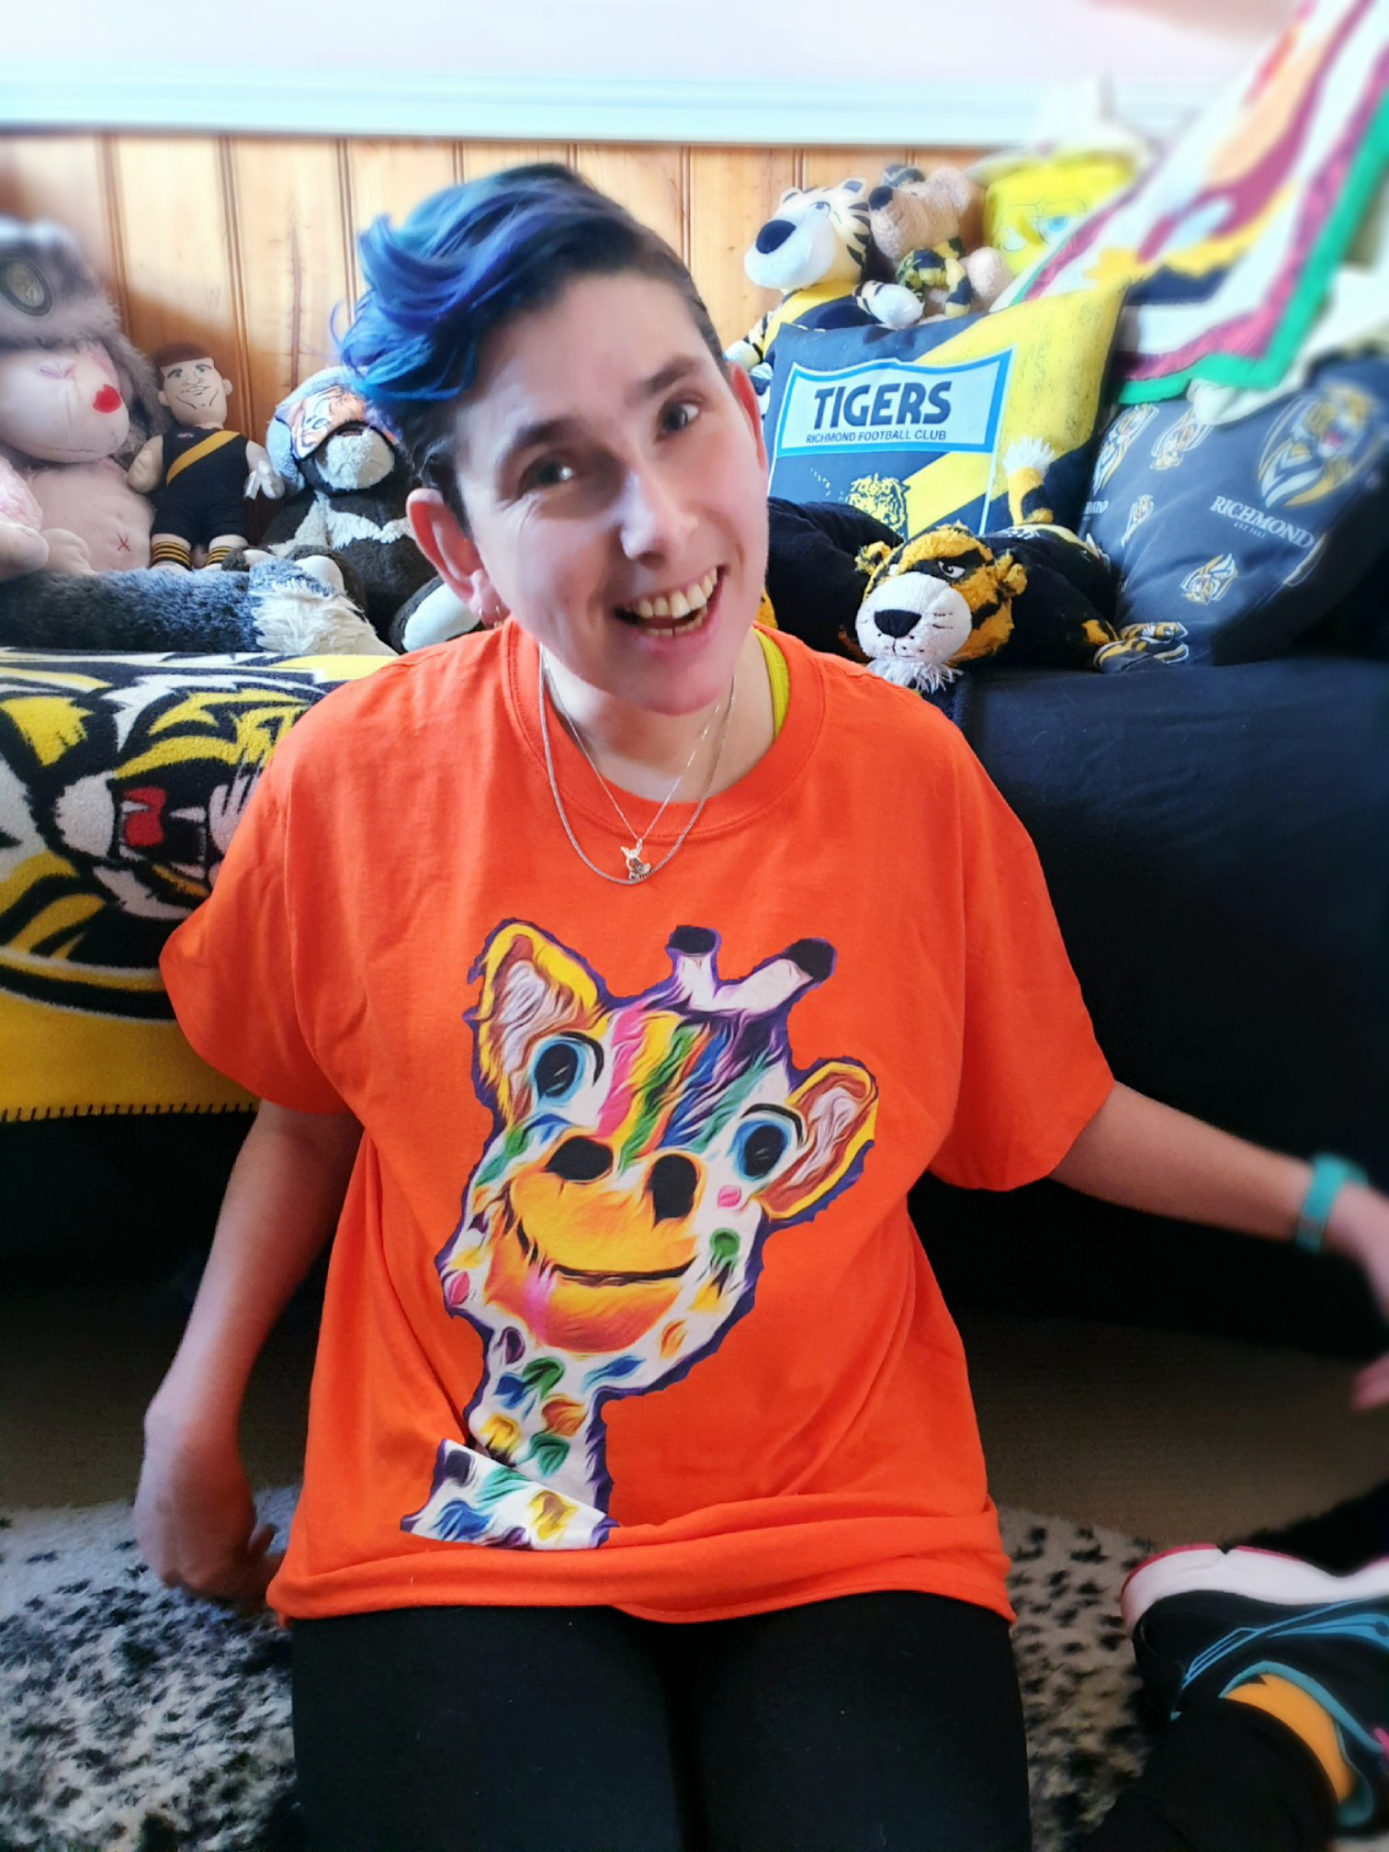

Professional Standards for Teachers
As well as being of direct value to children, Rafting: a wheelchair won’t stop us may also be a valuable prompt for learning in the context of senior secondary and Vocational Education and Training (VET) programs, and as a professional learning stimulus for adults in disability services or educational roles. The following Conversation starters and activities are just a few examples of the possibilities for teachers in schools, referring to the Australian Professional Standards for Teachers at the Proficient level.

Standard 1.1:

Use teaching strategies based on knowledge of students’ physical, social and intellectual development and characteristics to improve student learning
Conversation starter: How might assumptions about Trent’s intellectual and academic ability influence his teachers’ practices?
Activity: Reflect on a classroom learning experience you’ve designed and delivered recently. Propose any changes you’d make or any supports you’d provide if Trent was a student in your class.

Standard 1.6:

Design and implement teaching activities that support the participation and learning of students with disability and address relevant policy and legislative requirements.
Conversation starter: What adjustments could Trent’s teachers make to ensure his physical disability didn’t limit his learning?
Activity: Reflect on a school excursion or outdoor experience you’ve organised for students recently. Propose any changes you’d make or any supports you’d provide if Trent was a student in your class.

Standard 4.1:

Establish and implement inclusive and positive interactions to engage and support all students in classroom activities.
Conversation starter: How did the adults in Trent’s life help or hinder his peer relationships?
Activity: Identify the skills and opportunities Trent and his peers would need so that they could communicate and develop trusting relationships in your class.

Standard 4.4:

Ensure students’ wellbeing and safety within school by implementing school and/or system, curriculum and legislative requirements.
Conversation starter: Thinking about Trent’s rafting experience, what is the relationship between wellbeing and safety?
Activity: With reference to the Department of Education’s Procedures for Planning Off Campus Activities, suggest any changes to Trent’s rafting experience that would have been necessary if it was an activity organised by your school.

Standard 4.5:

Use ICT safely, responsibly and ethically.
Conversation starter: Why might social media represent an important form of communication for Trent?
Activity: With reference to the Department of Education’s Social Media Policy, suggest if and how you and your students might use social media in relation to a school camp or excursion.

Standard 7.3:

Establish and maintain respectful collaborative relationships with parents/carers regarding their children’s learning and wellbeing.
Conversation starter: If Trent’s rafting experience was a school activity, what communication with his parents/carers might have taken place?
Activity: Reflecting on a recent student report for or interview with parents/carers, identify the extent to which wellbeing was a focus (for you and for them). Propose ways in which you might enhance the assessment and reporting of student wellbeing.

Conclusion
The story of the rafting adventure of Trent and his friends is simple and positive. Trent’s friends are very important to him and they all want to do things together. By all of them working together, the friends make sure that all of them can enjoy the fun and adventure of the rafting trip. This story provides opportunities for lots of different classroom conversations about friendship, disability, inclusion, problem solving, and the process of writing and illustrating this book.

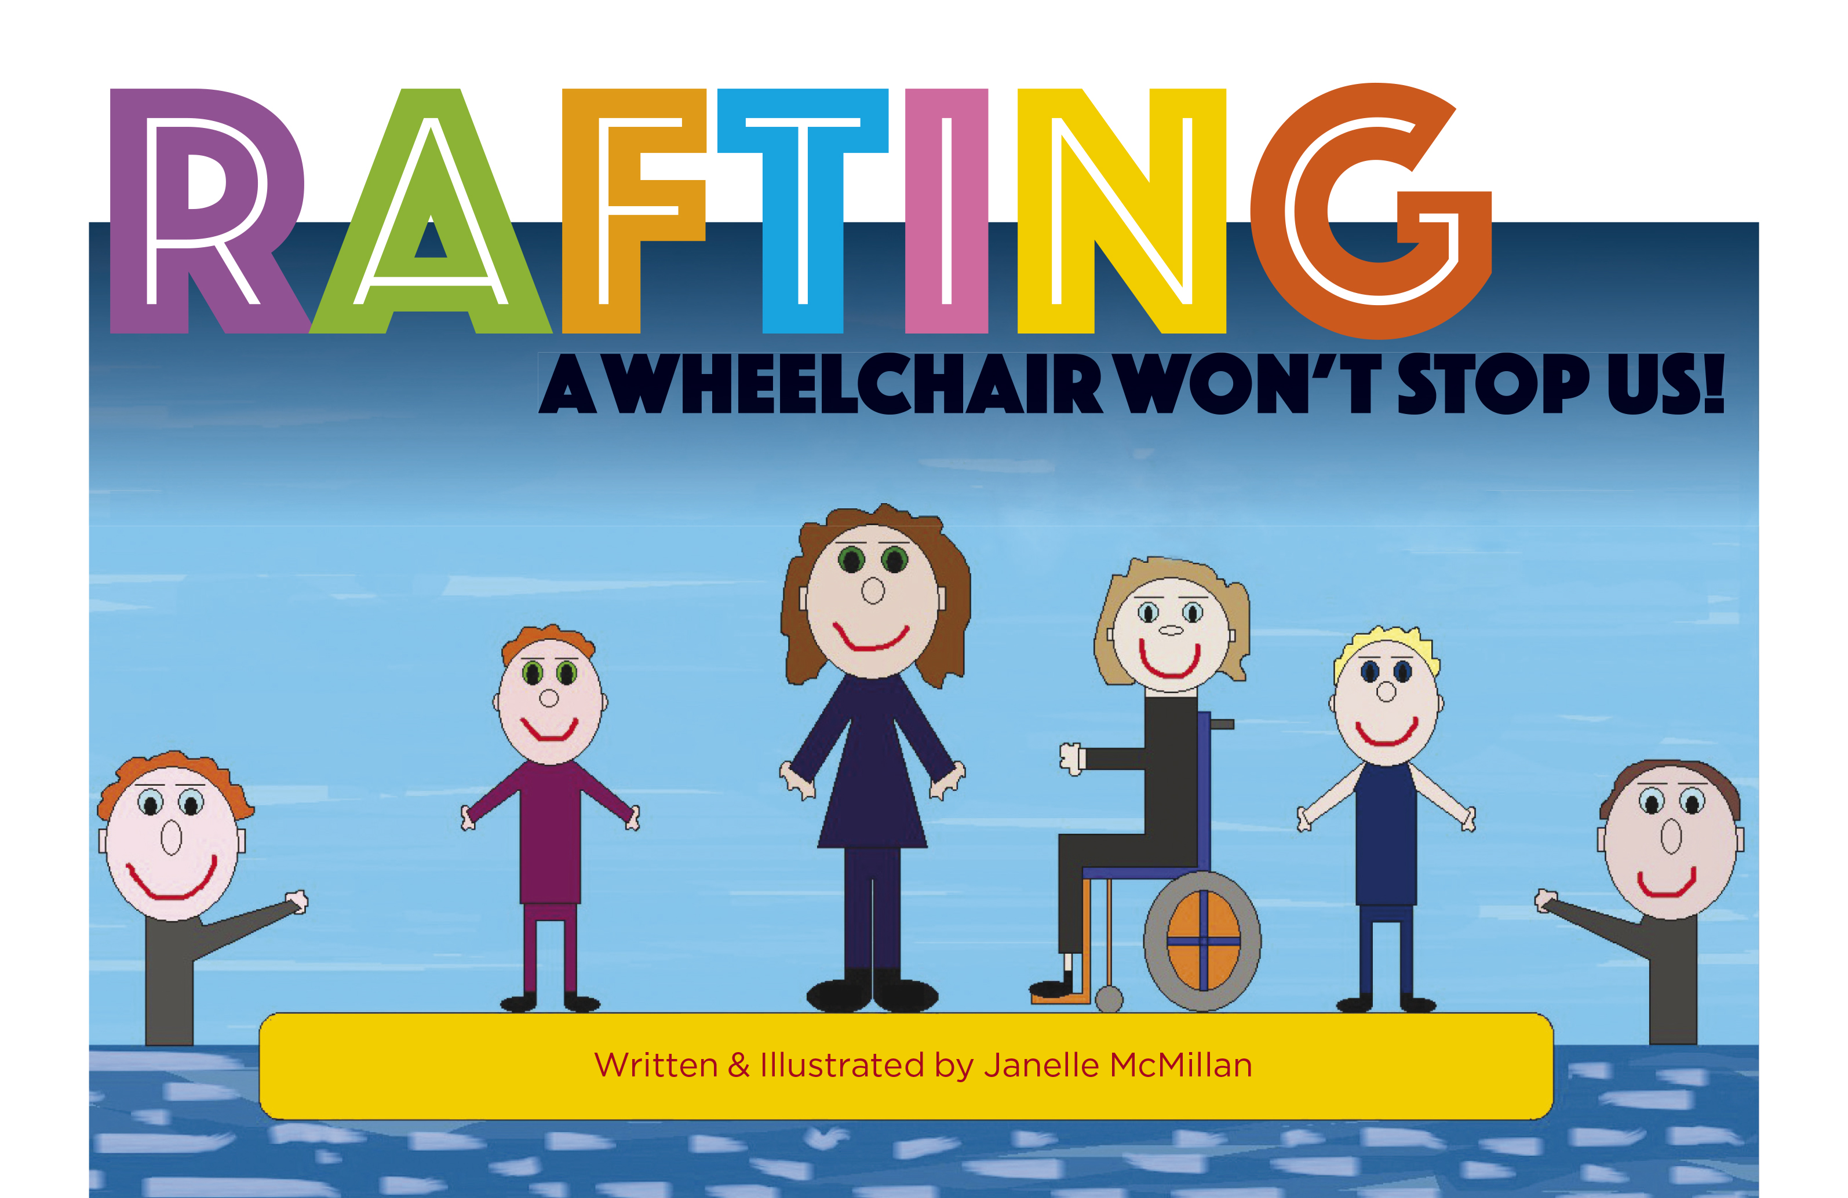

Bibliography

Online stories about Janelle
Janelle’s story: campaigning for change (undated, Disability Support Guide) <https://www.disabilitysupportguide.com.au/information/article/janelles-story-campaigning-for-change>.
https://think-tasmania.com/breast-cancer/
Janelle ‘Nell’ McMillan, ‘Try Living Life & Being Non-Verbal: Communication is everything in our world’ (June 2016) Intellectual Disability Australasia 3–4 <https://www.asid.asn.au/files/852_try_living_life_being_non_verbal.pdf>.
Meet Janelle McMillan, an amazing person who lives a life worth living (Bron Hogan, 14 June 2019) <https://bronhogan.com/meet-janelle-mcmillan-an-amazing-person-who-lives-a-life-worth-living/>.
Ponderings Radio interview https://www.buzzsprout.com/604348/3473275

Janelle’s art online
Janelle’s redbubble page is https://www.redbubble.com/people/nellyswheels/shop

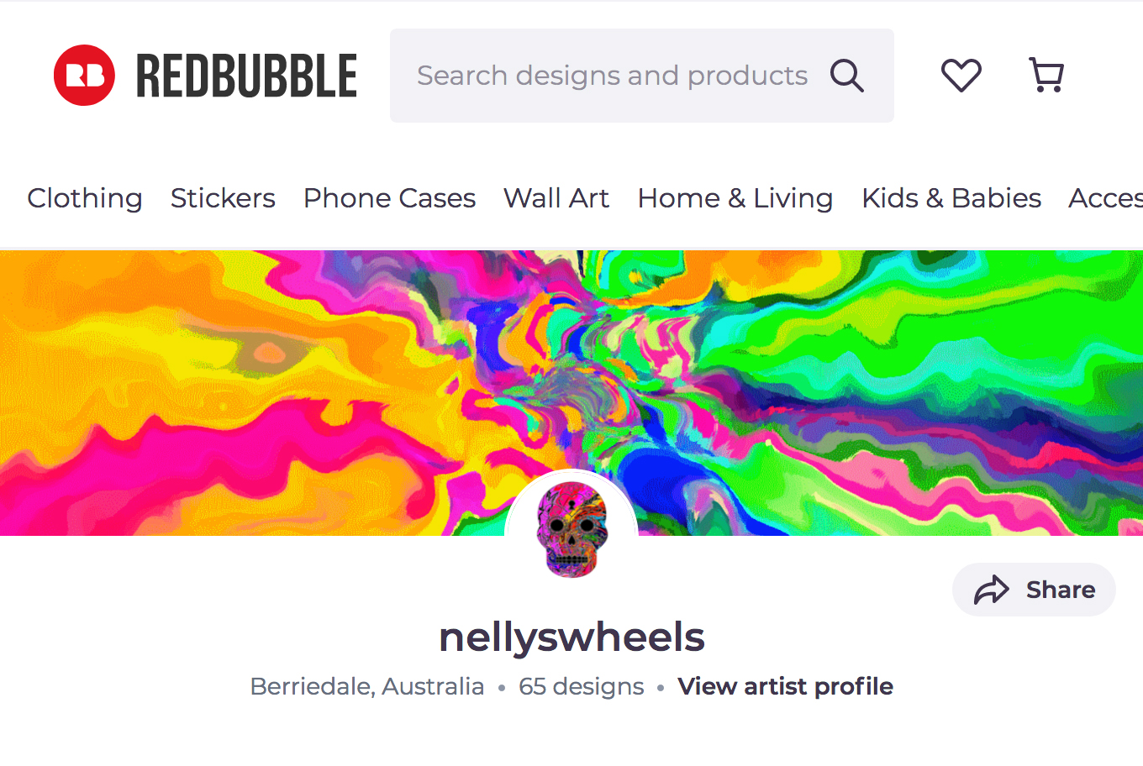

General video resources
ABC Me, ‘What it’s like to experience a disability’ (31 May 2018) <https://www.youtube.com/watch?v=7M6mN3JrOUQ> (6:41 minutes).
TheCGBros, ‘Ian’ (18 December 2018) <https://youtu.be/Hz_d-cikWmI> (9:51 minutes).
Sesame Street, Sesame Street and Autism (various dates) <https://autism.sesamestreet.org/videos/kids/> 25 short video resources for younger children:
- Spelling “Nasaiah” (1:16 minutes <https://autism.sesamestreet.org/video/spelling-nasaiah/> All children love to play! What’s your child’s favourite game?)
- Boing Tag (1:16 minutes <https://autism.sesamestreet.org/video/boing-tag/ Meet Julia, the newest friend on Sesame Street. Julia has autism. When her new friend Abby notices what a good jumper she is, the two friends invent a new game to play together: boing boing tag!)
- Saying Hello (1:29 minutes < https://autism.sesamestreet.org/video/saying-hello/> Different Ways to Say Hello with Julia and Rosita: we all communicate in our own way. Help kids explore and celebrate the differences!)
- Sunny Days (1:30 minutes <https://autism.sesamestreet.org/video/sunny-days/ Meet Julia, the newest friend on Sesame Street. Julia has autism. She’s also a really good singer and can remember all the words to lots of songs ... like her favourite Sesame Street song, “Sunny Days”. Abby’s happy to join in!)
- Julia’s Bunny (1:37 minutes <https://autism.sesamestreet.org/video/julias-bunny/> Meet Julia, the newest friend on Sesame Street. Julia has autism. She and Elmo are different in some ways, but they have lots in common too. Julia has a stuffed bunny named Fluffster, and Elmo has a doll named David. Join Julia, Fluffster, Elmo, and David as they play peek-a-boo!)
- Benny’s Story (1:39 minutes <https://autism.sesamestreet.org/video/bennys-story/> This video was created by Shane McKaskle and the visual artists at Exceptional Minds, a non-profit vocational school and working studio for young adults on the autism spectrum who are pursuing careers in visual effects and digital animation. Benny’s character is voiced by Shane McKaskle.)
- Learning Sign Language (1:39 minutes <https://autism.sesamestreet.org/video/learning-sign-language/> There are many different ways of communicating.)
- What Do You Want Kids to Know About Autism (1:47 minutes <https://autism.sesamestreet.org/video/want-kids-know/> Children describe autism in different ways—let’s celebrate and value all perspectives! What do YOU want kids to know about autism?)
- Butterfly Flapping (1:49 minutes <https://autism.sesamestreet.org/video/butterfly-flapping/> Meet Julia, the newest friend on Sesame Street. Julia has autism, and when she’s excited, she sometimes flaps her arms. When Abby is excited, she flaps her wings. Together, they’re the perfect pair to flutter like butterflies … and then watch a real butterfly land in the garden!)
- We’re Amazing, 1 2 4! (2:03 minutes <https://autism.sesamestreet.org/video/amazing-1-2-3/> What does your child have in common with Julia and her friends? How are they different?)
- Blowing Bubbles (2:05 minutes <https://autism.sesamestreet.org/video/blowing-bubbles/> Meet Julia, the newest friend on Sesame Street. Julia has autism. And, just like Abby, she loves bubbles! Julia and Abby share a magic moment of friendship as they relax, blow bubbles, and watch them float and pop.)
- Twinkle, Twinkle (2:06 minutes <https://autism.sesamestreet.org/video/twinkle-twinkle/> Meet Julia, the newest friend on Sesame Street. Julia has autism. She also likes to sing and look up at the night sky. She and Elmo stargaze as they sing “Twinkle, Twinkle” … and enjoy the magic of a starry night.)
- Each Family Is Amazing (2:14 minutes <https://autism.sesamestreet.org/video/each-family-is-amazing/> Julia and Rosita Celebrate Families: every family is different, and each member of a family is important. Celebrate families with Julia and Rosita!)
- I Love My Family (2:37 minutes <https://autism.sesamestreet.org/video/i-love-my-family/> Julia and her family sing—it’s fun spending time together!)

- Storytime with Julia & Samuel (2:39 minutes <https://autism.sesamestreet.org/video/storytime-julia-samuel/> Super Fluffster (Animated): Julia and Samuel make up an out-of-this-world story starring Super Fluffster—to the rescue.)
- The “Amazing” Song (2:40 minutes <https://autism.sesamestreet.org/video/amazing-song/> Watch this music video, then keep the beet going. Post your own video showing the amazing in your child!)
- Let’s Play Together (2:50 minutes <https://autism.sesamestreet.org/video/lets-play-together/> Julia, Rosita, and Grover Play Freeze Dance: every kid plays a little differently—and with some adult help, kids can usually find ways to play together!)
- Pattern Hunt (2:53 minutes <https://autism.sesamestreet.org/video/pattern-hunt/> Julia and Grover Search for Patterns: Julia’s great at slowing down and noticing details—and teaching Grover to identify patterns.)
- Starfish Hug (3:08 minutes <https://autism.sesamestreet.org/video/starfish-hug/> Julia and Sam’s Starfish Hug: Abby is feeling sad, so Julia and Sam cheer her up with a special kind of hug.)
- Behind the Scenes (3:12 minutes <https://autism.sesamestreet.org/video/behind-the-scenes/> Benny and his friends—and the friends who made this video ABOUT Benny and his friends—are all awesome! How are YOU like Benny?)
- A Starry Story (3:13 minutes <https://autism.sesamestreet.org/video/a-starry-story/> When her pet bunny wants to visit a faraway star, Julia uses her imagination—and a song—to reach for it.)
- Siblings Playdates (3:45 minutes <https://autism.sesamestreet.org/video/sibling-playdates/> Learning to Take Turns: When Julia and Samuel can’t agree on who gets to play with Superpup Rose, It’s Superhero Mega Mommy to the rescue.)
- Julia’s Family Gets Ready (3:48 minutes <https://autism.sesamestreet.org/video/julias-family-gets-ready/> Julia—and the whole family—helps Dad get ready for his saxophone gig at Hooper’s store.)
- Shape Hunt (9:53 minutes <https://autism.sesamestreet.org/video/shape-hunt/> Julia’s got a great eye, as her friends find out in this video!)
- Meet Julia (10:07 minutes <https://autism.sesamestreet.org/video/meet-julia/> Meet Julia, an old buddy of Elmo’s and the newest friend on Sesame Street. Julia has autism … and she and Elmo share an amazing friendship.)

A Note About This Project
Outside the Box – Earth Arts Rights was formed by four friends who want to connect, amplify, nurture and support people working at the intersection of environmental protection, the arts and social justice.
We would like to thank Judy Travers and Teresa Pocket from the Department of Education
and Christopher Rayner from the University of Tasmania, who gave their expertise and
time to this project with great enthusiasm.
The Outside The Box team is grateful for the major funding support on this project from Hobart City Council and Bellendena Small Grants Scheme.
Thanks also to Darren Greene and the printing team at Mystique for the beautiful print job on the book.
And to Lara van Ray from Small World Documentaries for the creative production of the
video that accompanies these notes.
Special thanks to Clive Tilsley at Fullers Publishing for championing this project.
And to Janelle McMillian, you are awesome!

Get in Contact
hello@outsidethebox.com.au
Do you have a project that would benefit from encouragement, experience, collaborations and determined support? Are you ready to make new connections, share your ideas, get a practical and creative boost from people with decades of experience and strong networks in the areas of environment, arts and human rights. Does any of this resonate? We might be able to help.

